
Skills Workshops for anyone Caring for a Loved One with an Eating Disorder

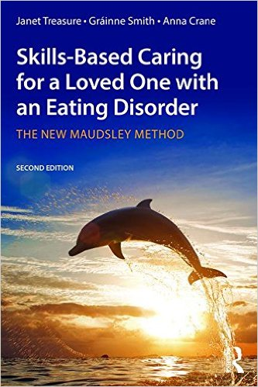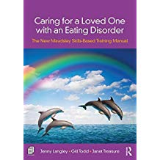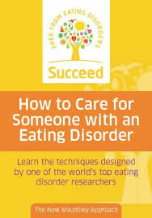

Caring for a loved one with an eating disorder can be exhausting, distressing and disorientating. Many carers feel they are drowning, they have tried everything and don’t know where to turn next. Well put on your oxygen mask and immerse yourself in these workshops based on the New Maudsley approach which has helped so many families to navigate their way through a seemingly impossible task. These workshops are full of practical tips, real life scenarios and case studies and are designed to help carers develop self-reflective skills in order to role model confidence, compassion and courage to take risks, and on how to experiment with changing their own behaviour so they can be more helpful to their Loved One.

Regular carer workshops are delivered by Jenny Langley in Sevenoaks Kent. For further details see www.newmaudsleycarers-kent.co.uk, jenny@newmaudsleycarers-kent.co.uk or 07887 840470

Ideally carers will attend all four two hour workshops in the series and a follow up session at a later date.

Collaborative Care New Maudsley Skills Workshops for Carers

‘The workshops provide outstanding support for carers. I feel much
better equipped to play a constructive role in my son’s recovery.’

The series of five two hour workshops is run on a rolling basis, as well as occasional one off follow up workshops to review, reflect and practice the skills.
The Maudsley Hospital recognises that family/carers are in a unique position to support their loved one to tackle the Eating Disorder, but are typically excluded from treatment, with the impact of EDs on family often overlooked.

In 2010 The Maudsley Hospital, leading ED inpatient and research centre, established a series of ‘Collaborative Care’ skills training workshops based on Janet Treasure's book, to provide carers with the practical advice and support that is so often requested. Jenny Langley was involved in the pilot of these workshops in Cambridge and has since developed the workshops, now with workbooks, to maximise the benefits for carers and their families.

These workshops offer professional techniques for becoming a
‘Change Coach’ for your loved one, including:
- Dealing with challenging behaviour
- Specialised communication skills
- Avoiding traps that may maintain the disorder
- Supporting recovery

Please contact Jenny Langley on 07887 840470, or jenny@newmaudsleycarers-kent.co.uk

‘Our relationship has improved massively. I really can’t recommend the
workshops highly enough, I almost feel like a different person now.’
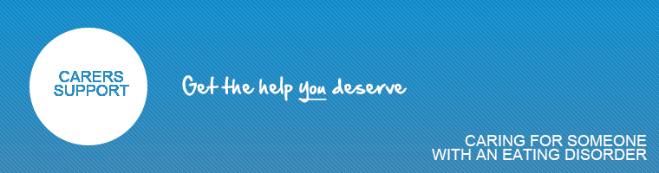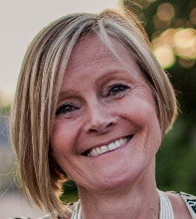
Jenny Langley
07887 840470
Youtube Channel : New Maudsley Training
ww.youtube.com/channel/UC2hNVzbQw1ZnU36R0DnA-Tw
trained by Beat and the Maudsley
Author: Boys Get Anorexia Too. New Maudsley Training Manual
Winner 2016 Royal College of Psychiatrists Carer Contributor of the Year
Winner 2014 Beat Education and Awareness Award
Charlie Waller Memorial Trust Associate Trainer, Mental Health First Aid Youth Instructor
Comments from Carers Who Have Attended the Kent Workshops Based on the New Maudsley Approach

“It means so much to my husband & myself that you have put so much work & effort into presenting this workshop with so much information, help, skills & given with fantastic enthusiasm which inspired & gave us hope that we could make a difference.”
“Thank you for your workshops, I feel inspired to try all we have learnt not just because of the workshop but of the enthusiastic, dynamic & professional way you communicate it to us”

“I want to thank you so much for your brilliant work shop. My partner gave you praise indeed for the professional yet interesting, intelligent clever way the work shop is presented & always thought provoking, which gives us so much support & material to work with, importantly it encourages us to hope”

“My husband and I are overwhelmed with the care & support we receive and the abundant benefits of your workshops. We feel very lucky with all the care from everything you organise”

“It has been a great comfort to have the support of the work shop for both of us. A big thank you for the 200% work & effort you put into the presentation /content, we are definitely the winners”

“You have helped us enormously in terms of increasing our knowledge and giving us confidence to deal with our daughter’s anorexia and the added issue of her ongoing depression. Not least, you have given us the means to communicate with each other. You are an inspirational woman, Jenny”
“Knowledge is empowering, and sharing problems is comforting even when we are forced to confront the horror of what has happened to our loved ones. Thank you for giving me the belief that my daughter can recover from her anorexia”
"When our daughter was ill coming to your group sessions at your home really helped us through an incredibly difficult period. We would never feel completely safe but if you saw x now she is doing so well especially through the rigours of GCSE's. Her weight is good and we have not had any food issues at all for probably the last six months. The moment for me was last Sunday coming hot from the BBQ with some large hamburgers. She picked up one with oil on the top and stuck it in a buttery brioche bun and then put on cheese etc on top without blinking at all. She seems happy and balanced. Long may it continue!!"
“I came away from your workshops thinking that if therapists had this type of training and input regarding eating disorders early in their training what a difference it would make because as amazing as it is there is to the best of my knowledge still, very little time dedicated to this subject whilst training” from a local Counsellor
Collaborative Care: The New Maudsley Model, Eating Disorders; Jenny Langley 2021
Comments from Eating Disorder Sufferers Whose Carers Have Undertaken the New Maudsley Approach

“Dear Jenny, I just wanted to send you a little note to thank you for all the support and help you’ve offered my mum throughout the past couple of months. I know how tough it has been for her to see me struggle with my eating disorder since I came home from university and the weight she carries to be my rock on the really difficult days. I could not have come this far in my recovery without her and I don’t believe she could have done it without you. It takes a village and I am so fortunate to have one in my corner.”

“I felt they (my parents) became “lighter” and “freer” somehow. It gave them comfort that other people face the same issues, the same problems, the same challenges. They were then less stressed around me.”

“It was like for years they (my parents) were just trapped with me in my illness. They wouldn’t leave me on my own, wouldn’t go on holiday, out to the cinema or anywhere. The whole family just lived through and focused on my eating disorder. It was like we were trapped in a bubble. The book I think gave them scope to look outside the illness in addition to caring; to take time just for them, to do things they enjoyed, to live their lives instead of living everything through me and my illness.”

“I feel it really helped and the main thing that helped was her staying calm…it really, really helped...when she stays calm, I sort of stayed calm myself and just got over it”

“She recognises that I have AN, it’s not just my personality…and it’s the AN she hates... I like that she sees it as separate in one way because it makes me know that she doesn’t hate me”

“I think my Mum realised that if my life was going to change, I had to want it to. She left more decisions up to me and gave me extra responsibilities. It was hard not to abuse her trust at times but the guilt and sense of shame I had if I did was unbearable. I think if she hadn’t have “taken a back seat” I would have just stayed stuck for years”

“I think mainly the confidence thing…before they felt panicked; they didn’t know what to do…so I think the confidence was the biggest one”

“Her attitude towards me has got a thousand times better”
“I knew from the start that Mum and Dad were attending your sessions. Mum and Dad were so overwhelmed by what was happening to me, and I think that your sessions helped them to appreciate anorexia and what it was doing to me a little better. I think it helped them to comprehend that it wasn’t always me that was fighting them, but it was more the anorexic part of me that was being so nasty. I think it also helped them to feel less alone.”
Collaborative Care: The New Maudsley Model, Eating Disorders; Jenny Langley & Janet Treasure et al 2021
Research Rationale
Eating disorders have a social context that draws others into the illness. The symptoms of an eating disorder very soon play a central role in family life – normality disappears, social life disappears, future plans are put on hold and interactions around food increasingly dominate all family relationships. Understanding how families reorganize their lives around a problem, however, is far more important from a treatment point of view than knowing how that problem developed, Eisler (2005).
When living in the midst of an eating disorder, families frequently become bullied into what they eat, how they eat, where they eat or when they eat. It is only natural that they frequently respond in a manner that accommodates the symptoms in a bid to keep the peace.
Our intervention is based on a cognitive interpersonal maintenance model which proposes that interpersonal factors (overprotectiveness, hostility, criticism, accommodation and enabling) can develop within families and maintain the illness (Schmidt & Treasure, 2006; Treasure & Schmidt, 2013). Inadvertently, these may hinder recovery. These are modifiable behaviours, however, and it is thought that carers may benefit from skills training in aspects of eating disorder management, similar to those used by professionals in specialized inpatient services (Rhind, et al., 2014).
Consequently, skills include the use of motivational interviewing as a means of providing calm and compassionate meal support, engaging intrinsic motivation to change. Carers are also taught the application of behavior change principles and about the cognitive and emotional styles associated with eating disorder behavior. Skills and techniques include:
- Strengthening carers’ beliefs in their abilities to make change possible
- Giving carers the opportunity to express concerns about the illness
- Discussing the basic principles of behaviour change
- Teaching communication skills (ability to express & process emotions)
- Promoting respect, satisfaction and a unified approach within the family
- Learning the skills of problem solving
- Maximizing carer skills (warmth with limits and boundaries)
- Highlighting those factors which may be aggravating the problem

Collaborative Care: The New Maudsley Model, Eating Disorders; Janet Treasure et al 2015

Research Findings
Our team of researchers, trainers and carer coaches have considerable experience of working with carers of people with eating disorders. Several past and more recent research studies have shown that skills training programmes, such as the New Maudsley Method have shown high carer acceptability (Treasure, et al., 2007b; Sepulveda, et al., 2008a; Sepulveda, et al., 2008b). In the DVD and manual iteration of the programme, delivered in a DVD/manual format, there were significant reductions in carer anxiety and depression, expressed emotion, burden of care and accommodation to eating disorder behaviours and unwitting enabling as well as significant increases in carer psychological wellbeing and self-efficacy. Carers also reported an improvement in the wellbeing and eating disorder behaviours of the sufferer (Goddard, et al., 2011). Results of qualitative studies have also shown high acceptability from both carers (Macdonald, et al., 2011) and patients (Goddard, et al., 2010).
Also, in a web based format carers mood was greatly improved (Grover, et al., 2011a; Grover, et al., 2011b). Patients themselves reported that they found it helpful that their carers/parents understood more about the thinking and emotional processes associated with an eating disorder.
Data from a full multi-centre RCT, Carers Assessment Skills and Information (CASIS) project, that tested the effectiveness of carer skills training for families of adult inpatients, was associated with reductions in carer time spent care giving, caregiver burden and unhelpful care giving behaviours (Hibbs, et al., 2015). Patients had reduced eating disorders psychopathology and improved quality of life at 6 months post discharge and a marginally improved trajectory at one year. The ECHO group had marginally reduced service use with shorter inpatient stays and a longer time before readmission. Qualitative data from the same study showed that patients could identify positive caregiver behaviour changes targeted in the intervention (Macdonald, et al., 2014). Data is currently being analysed for another multi-centre RCT that compares guided self-help and self-help to treatment as usual.

Collaborative Care: The New Maudsley Model, Eating Disorders; Janet Treasure et al 2015

Carers' Needs Why?

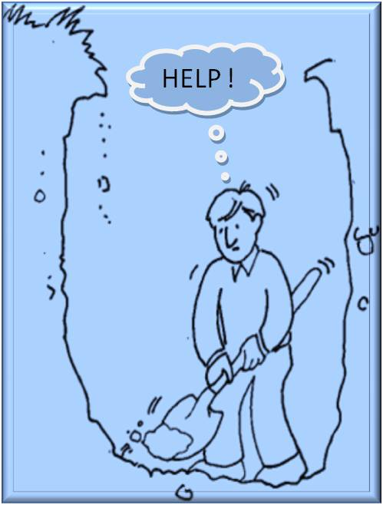
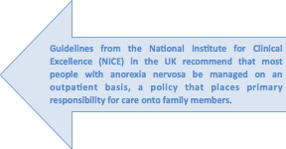

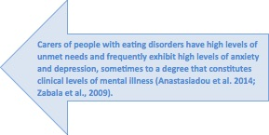

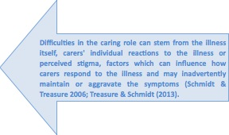


Collaborative Care: The New Maudsley Model, Eating Disorders; Janet Treasure et al 2015

